Additional Information and Important Papers
2026 - 2027
(Updated 6/22/26)



Gregory S. Dingwall, Ed.S., Director

120 Melvin Johnson Dr.

Livingston, TN 38570

Livingston Academy Band

Fall Semester 2026

Phone: 931-823-5911 x292

Fax: 931-823-8834

Email: gdingwall@oc-sd.com

Website: www.la-sotw-band.net

Parents and Students,
First please be aware that after school rehearsals start Monday Aug. 10, 2026, and they are every Monday, Tuesday, and Thursday from 2:45 pm - 4:30 pm until the end of Marching Season and beyond. Regular Band classes are during school 6th (sixth) block. As needed, all uniforms should be adjusted and ready for the season by Friday Aug. 14, 2026. All uniforms stay hung up and in the band room, not at home.
Show shirts should be in and any extra shirts that are left over are $20/$25 each. Please turn in money in for those, asap! Lastly, please be aware of the schedule (posted on the website and in the Band Room) and take note of all games and contests. Also note that there is not a Home or Away Game scheduled on Friday Oct. 16 (the last Friday of Fall Break). We also need parents to help work concessions at any Home Game as well as at the 4th Annual Northern Plateau Marching Invitational on Sat. Sept. 12th, 2026, we still need to make sure 3rd Quarter Break (is continued), the Band get-together (Fellowship).
Please note the forms attached to this letter, they need to be filled out and returned by Friday, August 14, 2026
.

Thank You,

Gregory S. Dingwall
Gregory S. Dingwall, Ed.S., Band Director



Livingston Academy Band

Phone: 931-823-5911 x292

Fax: 931-823-8834

Email: gdingwall@oc-sd.com

Website: www.la-sotw-band.net

Gregory S. Dingwall, Ed.S., Director

120 Melvin Johnson Dr.

Livingston, TN 38570

Summer Band Info & Dates 2025
Tentative
Dates: Night Rehearsals, may be used if the weather during the day is overtly extreme.
Other dates of interest:
Fundraising Event TBA (April or May) – 8:00 am -12:00 pm, will do a mass mailing to local and community businesses for their support this coming year.
LA Band Carwashes: May 30th, 2026 – 7:30 am – 2:30 pm, O’Reilly’s
June 13th, 2026 – 7:30 am – 2:30 pm, O’Reilly’s
June 27th, 2026 – 7:30 am – 2:30 pm, Advanced Auto
July 11th, 2026 – 7:30 am – 2:30 pm, O’Reilly’s
July 25th, 2026 – 7:30 am – 2:30 pm, Advanced Auto
Pre-Band Camp: July 8th – 10th, 2026 – Leadership: 8:00am – 4:30pm
July 9th, 2026, 6:00 PM LA Band Room, at 6:00 PM Parent Meeting (Mandated)
Band Camp Week 1: July 13th – 15th, 2026 - Color Guard, Percussion and Leadership: 8:00am - 4:30pm
Band Camp Week 2: July 14th – 15th, 2026 – Marching Fundamentals, Drill, All Band Members: 8:00 am – 4:30 pm
Band Camp Week 3: July 20st – 24th, 2026 – Drill placement/ Show, and Pep Band, All Band Members:
8:00 am – 4:30pm, Full Band Rehearsal
July 24th, 2026 – 3:00 pm - 1:00 am, DCI Nashville, Titan’s Nissan Stadium
Band Camp Location: LA Band Room & Practice Field (old tennis courts behind the building, near band room)
Color Guard: included in all the dates, above.
LA Band website: www.la-sotw-band.net, www.lasotwband.com
Important Notes: Band Camp Week 1, Week 2 and week 3 are required - mandatory camps for ALL Band Members, as descibed above. These camp dates involve learning basic marching techniques, music, and practicing for our fall marching show, as well as our pre-game. These camp dates will include music rehearsals, warm-ups, sectional practice, marching fundamentals, and drill work, etc... If you do not attend Our Band Camp, Week 1(Percussion and Color Guard), Week 2 and Week 3,ALL BAND MEMEBERS, a spot IS NOT guaranteed for you in our fall show. (Communication with the Director is very important.)
Food: snacks and drinks you will need to provide; lunch will be provided again this year, from the school summer lunch program.
Clothing: Wear light colored clothing, light weight clothing, shorts, t-shirts, tennis shoes (required), and an extra pair of socks. Students can also wear a hat to cover their heads and faces from the sun. Water bottles, sunscreen, sunglasses, snacks, and extra clothes for inclement weather are also good ideas.

There are 6 home football Games and 4 away Games (may not travel to all the away games), there are also numerous festivals and competitions we attend on Saturday’s and you are required to participate in all of these. Parades are also a part of what we do. There is a fee which we ask for and is not covered under the fee waiver program of Livingston Academy (and we’ve asked), this is to be paid by all band and color guard members. Our show for the fall is scheduled to be “Outlaw”, by Luke McMillan. If you have any questions, please call or email me, Thank you.



Livingston Academy Band
Gregory S. Dingwall, Ed.S., Director
Livingston Academy High School
120 Melvin Johnson Drive
Livingston, TN 38570-8242

Phone: 931-823-5911 x292

Fax: 931-823-8834

Email: gdingwall@oc-sd.com

Website: www.la-sotw-band.net

2026- 2027 Leadership Team
Drum Major
TBD
Band Captain
TBD
Woodwind 1st Lieutenant
TBD
Woodwind 2nd Lieutenant
-
Brass 1st Lieutenant
TBD
Brass 2nd Lieutenant
-
Percussion 1st Lieutenant
TBD
Percussion 2nd Lieutenant
-
Logistics 2nd Lieutenant
-
Color Guard 1st Lieutenant
TBD
Color Guard 2nd Lieutenant


Student - Band Clothing Size Form Worksheet

Livingston Academy Band

This coming year all Band Students will be required to have a Band Ball Cap, Band Show Shirt-Gray, patch, as well as the Band Polo Shirt. Students will wear the ball cap to all atheltic type events and wear in the stands instead of their shakos. The polos will be for Concert Band Performances and travel (students will also need dress pants/khakis and plain black dress shoes). Extras may be purchased at our cost. Please fill out the order form below and return with your sizes indicated as well as payment, if needed.

Gregory S. Dingwall, Ed.S., Band Director

Student Name: ______________________________
Band Show Shirt-Long Sleeve – (Part of dues)
Size Needed: _________ – SM – XL
– 2XL – 4XL
# Needed: _______
Band Ball Cap – (Part of dues)
Band Patch - (Part of dues)
Band Polos - (Black) – (part of dues) (For Concerts
and Travel)
Size Needed: ________ – SM – XL
-2XL – 4XL
# Needed: __________
There is a $5 increase for all sizes 2XL and up

Band Show Shirt-Short Sleeve – (Not part of band dues)
Size Needed: ________ ( $20 – SM – XL )
( $25 – 2XL – 4XL)
# wanted: ________

Band Shorts - $15 (Not part of band dues)
Size Needed: _________
# wanted ______

Band Beanie - $15(Not part of band dues)
# Needed: _______

Band Jacket - (Not part of band dues ($50– SM – XL)($55 – 2XL and up)
Size Needed: __________
# wanted: ________

Band Scarf – $15(Not part of band dues)
# Needed: ____________

Shoes – Black (Not part of band dues)
(Mens), (Womens) – circle one
Size: ___________ ((Extra Wide) – circle if needed) - $40.00 each pair

Gloves – Black $4.00 ( Band gives first pair, additional gloves you pay for)
Socks – Black Athletic $4.00

(Guard Only)
Guard Pants - $40
Size: ______________ # Needed: _______
Guard Practice Flags - $40
# Needed: _______
Flag Color Preference: ___________________

Uniform Dry-Cleaning dues: $50
(All except guard, unless reg. band after marching season, then $30)

Make checks payable to LA Band Boosters

Livingston Academy Band

LA Band Dues Work Sheet
Band Dues: Band Dues are established in order to help meet the needs
and obligations of the Band Program. The Band Camp Dues are based on the
cost of bringing in additional teaching staff benefiting the musical growth of our students. The Band Dues structure is as follows:
Band Camp Dues: $150 per member(everyone)+
Regular Band Dues: Show Shirt - $20/$25*+
Band Polo - $50/$55*
Ball Cap - $20+
Show Patch - $5 +
$245/$255*
Uniform Dry-Cleaning Dues: $50 (Winds & Percussion Only)
Total Regular Band Dues: $295/$305 + $295/$305

Band Camp Dues: $150 per member(everyone)+
Regular Band Dues: Show Shirt - $20/$25*+
Band Polo - $50/$55*
Ball Cap - $20+
Show Patch - $5 +
$245/$255
Total Color Guard Dues: $245/$255 # $245/$255
Color Guard in Concert Band $30 (cleaning dues) # ( $275/ $285)
Other Band Dues (Only - if or as needed per member)
(If you need something select it and add, If you want something
also add)
Band Shoes - $45(needed)
Band Jacket - $50/$55* (optional)

Add’l Color Guard Dues: Guard Pants - $40 (needed)#______
Practice Flag, Pole and Accessories - $40 (needed)# ______

Other Cost: Black Gloves - $4 (First pair provided by the Band,
After that, you Buy)
Black Socks - $4 (Per pair If you don’t provide your own)

Band Dues are established in order to help the Band Program advance and meet the band’s needs and obligations through out the year. Please see the attached Dues schedule.
The band dues are set in lieu of the funding we receive from the school system. We receive $1000 per year.
(Individuals that can’t afford the dues are still able to participate in the band program, ability to pay is not a requirement)
The band dues are established due to the limited funding we receive from the school system.
*(Please see T-shirt or jacket size chart (on order form) for additional charges on 2XL and larger)
Make Checks Payable to the LA Band Boosters

Grand Total =

Gregory S. Dingwall, Ed. S., Director

120 Melvin Johnson Dr.

Livingston, TN 38570

Livingston Academy Band


Phone: 931-823-5911 x292

Fax: 931-823-8834

Email: gdingwall@oc-sd.com

Website: www.la-sotw-band.net

Dues Payment Agreement/Arrangement:

This agreement/arrangement is between the LA Band Program/ Boosters and named student and parents. The parties listed below agree to make regular payments (if possible) of a designated amount on a,
1. weekly/ once a week
2. bi-weekly/ twice a month
3. monthly/ once a month
basis until student dues are paid in full. We appreciate every effort to fulfill this financial commitment of the student and family in meeting the needs of the Band program.

Amount of dues: Total: __________________

Amount of commitment (if possible) to pay per payment: ________________

Payment Schedule: ____ 1; ____ 2; ____ 3 (please check one) (see above)

Student Signature: _________________________________________________

Parent Signature: __________________________________________________

Directors Signature: ________________________________________________

Thank You
Gregory S. Dingwall, Ed. S., Band Director

Date: _____________________________

Payments: Amount & Date:
____________, __________, _________, _________, _________, __________,

____________, __________, _________, _________, _________, __________.
If the parties are not able to afford the dues please contact Mr. Dingwall to discuss the situation.



Livingston Academy Band

Phone: 931-823-5911 x292

Fax: 931-823-8834

Email: gdingwall@oc-sd.com

Website: www.la-sotw-band.net

Gregory S. Dingwall, Director

120 Melvin Johnson Dr.

Livingston, TN 38570

Request for Alternate Transportation for Band Events
Date: ____________,2026-2027
By signing, you the parent/guardian of said student abide by the following statement,
I hereby grant permission for ______________________________ __________ to ride home with us their Parent(s)
(Student’s Name) ( Grade)
________________________________________ and/or a Designee _______________________________________,
(Parent(s) Name) (Designee Name)
Or drive themselves in extra-ordinary circumstances if that should arrive, following a music event(s). All students are required to ride to and from any event in school provided transportation, operated by an employee of the school. In the event that transportation is not provided by the school(s), I will be responsible for my student’s travel to and from said event. It is further understood that the purpose of this policy is for the safety and protection of the student(s) and that by signing this form, Therefore release Livingston Academy, the Livingston Academy Administration, the LA Band Program or the Band Director(s) and/or The Director of Schools, Overton County Schools/Board of Education ,successors, and assigns from any and all claims, causes of action, judgements or demands which they (parent/guardian) and/or their minor children (son/daughter) may have now or in the future, will not be held liable or responsible for any incidence that may occur while the student is in the care of us their parent(s) or their designee, or themselves.
The parent or the designee must speak with Mr. Dingwall to ensure proper pickup or drop off, of their student(s) prior to leaving the event.

_______________________________________ ____________________________
Parent’s Signature Date
Mr. Greg Dingwall, Ed.S. LA Band Director

Release of Liability Statement
By signing above, I/We the parent(s)/guardian(s) of students at Livingston Academy, understand that school policy requires all students to ride to and from activities in school vehicles, operated by an employee of the school, and further understand that the purpose of such policy is the safety and protection of students, do nevertheless, by signing this form, release Livingston Academy, its officers, directors, agents, employees, successors, and assigns from any and all claims, causes of action, judgements or demands which they (parent/guardian) and/or their minor son/daughter may have, now or in the future, because of any injuries which may be incurred as a result of their Child’s being allowed to drive himself/herself to and from activities, including any claims arising from negligence committed in the future. Also, if a parent/guardian signs this
form allowing their son/daughter to ride with them (parent/guardian) or another parent/guardian, as a convenience for themselves. This action
releases Livingston Academy, its officers, directors, agents, employees, successors and assign from and against any and all claims, cause of
action, judgements, demands, losses and expenses, including attorneys’ fees, arising from the use of their own vehicles to transport the named student(s).



Livingston Academy Band

Phone: 931-823-5911 x292

Fax: 931-823-8834

Email: gdingwall@oc-sd.com

Website: www.la-sotw-band.net
www.lasotwband.com

Gregory S. Dingwall, Ed. S., Director

120 Melvin Johnson Dr.

Livingston, TN 38570

Home School (Only) Student Participation Agreement:

This agreement is between the LA Band Program, it’s Director and named student and parents. The student and parents agree to bring the student(s) to summer band camp, regular band rehearsals Monday through Friday 1:30 pm – 2:35 pm, and for all called afterschool rehearsals as determined by the director (usually Mon., Tues., and Thurs. from 2:45 – 4:30 PM), and ALL football games and competitions. If said parties cannot agree to these stipulations, then it will be highly recommended that the student(s) may forgo participation in the Band Program.
Each person’s participation is integral to the overall sound and balance of the ensemble. When a student(s) miss rehearsals, the sound is different and the balance is off, so it is important for everyone to be present for rehearsals. This helps the Band achieve its highest potential. Students with inconsistent attendance cause us to be less than our full potential.
If the student(s) need to miss a rehearsal, then communication with the director is important and arrangements must be made.
With this agreement, all parties agree to the student’s participation in the band program

Student Name: ___________________, email: __________________________
Phone #: __________________

Parent/Guardian Name: ______________________, email: ________________
Phone #: __________________,
Address: ______________________________

Student Signature: _________________________________________________

Parent Signature: __________________________________________________

Director’s Signature: _______________________________________________

Thank You
Gregory S. Dingwall, Ed. S., Band Director Date: ________________

Livingston Academy Music Department
Overton County Schools
MUSICAL INSTRUMENT LOAN AGREEMENT FORM

This agreement is established between the Livingston Academy Music Department, Band Program

and __________________________________, whose student ____________________________________
(Parent’s Name) (Student’s Name)
will be loaned an instrument to use during the current school year.

The above-mentioned borrowers are Fully and Financially responsible to maintain the instrument (indicated below) while on loan to the student. Any damage (other than normal use) will be charged to said borrowers up to and including replacement of the instrument at current replacement prices. This includes shipping, handling and any taxes.

Borrowers must agree to this policy before the instrument (indicated below) will be loaned to their student. By signing below, you are acknowledging to and agreeing with the above stated responsibilities.

The Band Director reserves the right to cancel this agreement at any time without prior notification.

______________________________ ______________________________
Student’s Name (printed) Student’s Name (signed)

______________________________ ______________________________
Parent/Guardian’s Name (printed) Parent/Guardian’s Name (signed)

______________________________________________________________________________
Home Address City State Zip Code

__________________ ________________ _________________________________
Home/cell Phone # Work Phone # Email Address

________________________________
Band Director (signed)

Instrument Information

Make: __________________________ Type/Kind: __________________________
Brand: __________________________ Model: ______________________________
Serial #: __________________________ BOE #: ______________________________

Description/ Accessories: _________________________________________________________
_________________________________________________________

This instrument may be checked out for use during the summer, upon the approval of the Director
Date Loaned: ________________________ Date Returned: __________________________
Date Loaned (Summer): ________________ Date Returned: __________________________
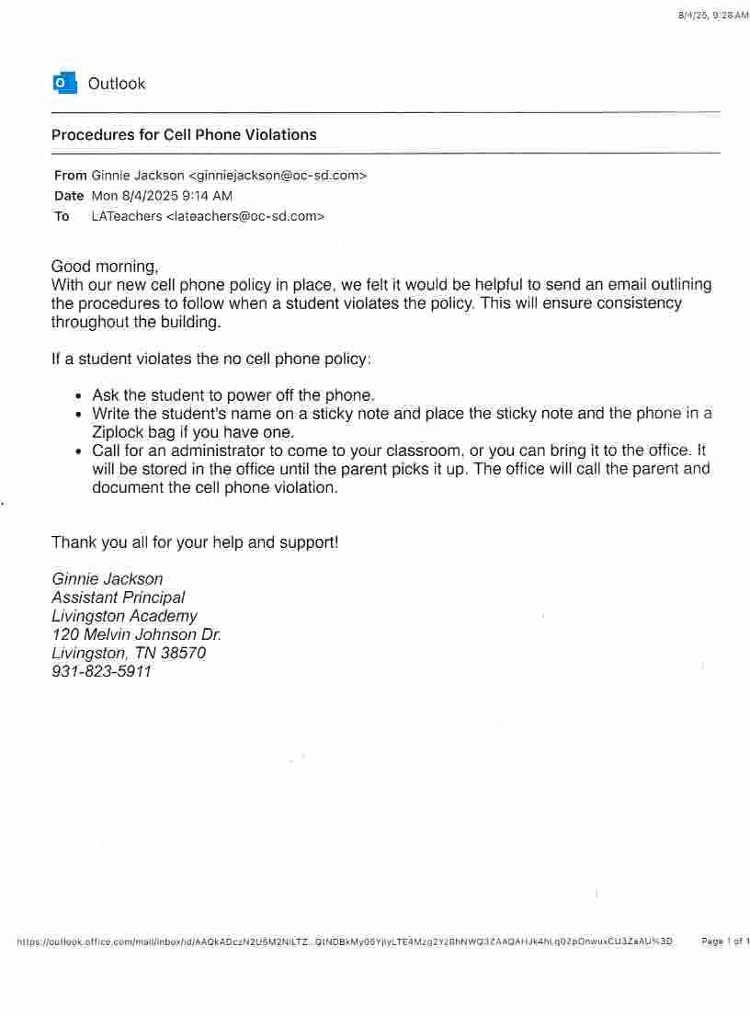


Extracurricular Activities Release Form
Student’s Name:_____________________________________

Parents’/Guardians’ Names:____________________________________________________________

Home Phone: _________________ Work Phone: _________________ Cell Phone: _________________

As the parent or legal guardian of the above-named student, I hereby give consent for the student to participate in the following named extracurricular activity/activities offered by the school district:
________________________________________________________________________________________________________________________________________________________________________________________________________________________________________________________________________________________________________________________________________________________________________________________________________
This consent includes travel to, and full participation in, all practices, rehearsals, meets, games, contests, competitions, meetings and events covered by the activities listed in this release. I further consent to treatment deemed necessary by medical personnel sought by any representative of school district for any illness or injury to my child that may occur in pursuing the above enumerated extracurricular activity/activities. I also consent to abide by all of the school district guidelines and policies governing my child’s participation in the above-named extracurricular activity/activities. This includes such policies as academic requirements, expectations for behavior, homework and test expectations, attendance, missing classes, leaving class early, etc.
For all athletic extracurricular activities, I agree to obtain a physical examination by a Medical Doctor licensed to practice in Tennessee (Physician) to ensure that my child is capable of full participation in the above-named athletic activity. I will provide a copy of the Preparticipation Physical Exam Form signed by the Physician prior to the first participation event. If there are any limitations on participation in such extracurricular activity, I will review them with the coach/athletic director who will determine if these limitations can be accommodated and who will make the final determination if my child can successfully participate.

Signature of Parent(s): ____________________________________________Date: _________________
Date received by the school office: _________________

Please return this form to Mr. Dingwall.

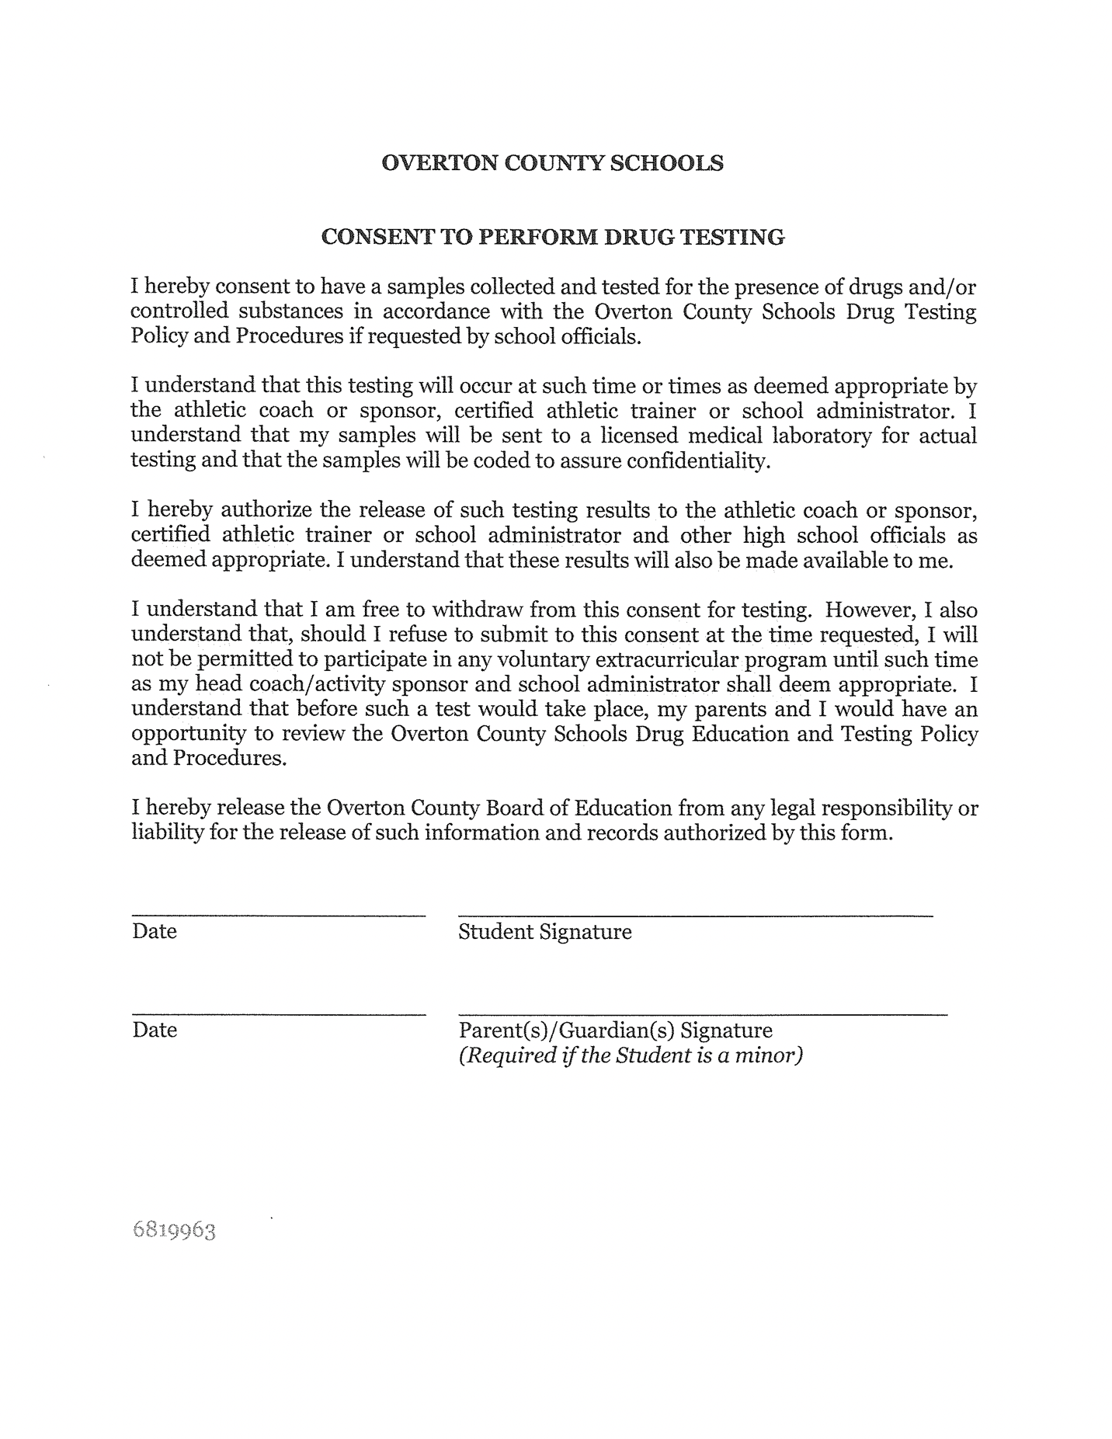

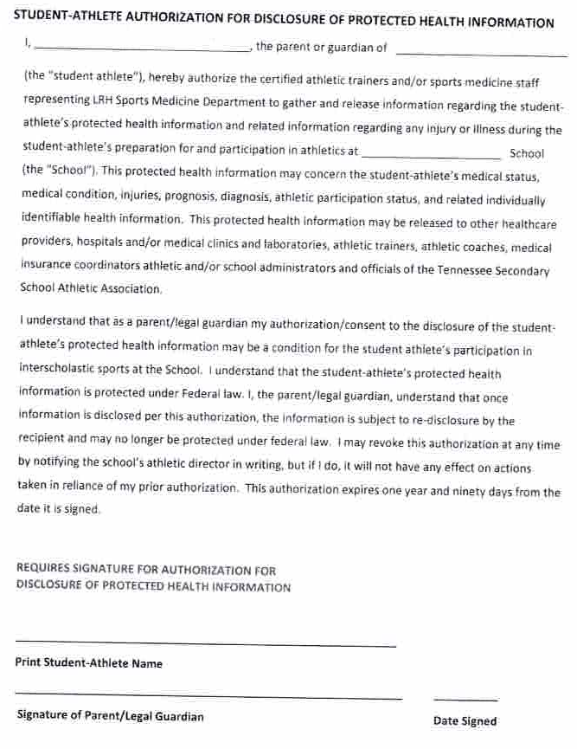

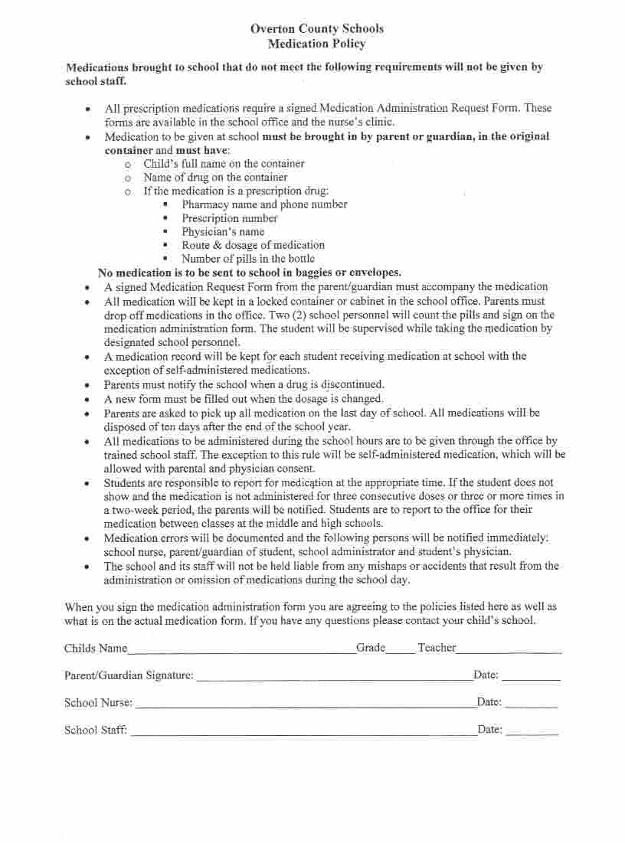

The Livingston Academy High School Music Department
Student Info, Medical, Health, Travel & Photo Release Form 2026-2027

IMPORTANT! PLEASE READ: This Medical/ Health/ Travel/Photo Permission form will be kept with the medical kit at all times in case of a medical emergency involving your student. Make sure ALL blanks are completed on both sides (page 1 and 2). If an item does not apply to your student, please put N/A in the blank to insure accurate information. Incomplete forms cannot be accepted. Please make sure that the primary and secondary contact is someone who can be contacted at anytime while your student is participating in a band activity. Please make sure the form is NOTARIZED before returning. Thank you. Not required but very helpful.

Student’s Full Name: __________________________________________________________________ Birth Date: ______________________________________
Sex: ______ Ethnicity:___________________ Race: ____________________ Grade: ___________ Instrument/Position: _________________________________

Primary Emergency Contact* _________________________________________________________ Home Phone______________________________________

Work Phone: __________________________ Cell or Other Phone: _____________________________ Email: _________________________________

Secondary Emergency Contact* _______________________________________________________ Home Phone: ______________________________________

Work Phone: __________________________ Cell or Other Phone: _____________________________ Email: _________________________________
*The Primary and Secondary contact must be able to be reached at any time when the student is participating in a band activity if the student’s parent/guardian are not in attendance.

Responsible Party (in case a hospitalization is required): _____________________________________________ Home Phone: ___________________________

Address & Zip: ______________________________________________________________________________________________________________

Work Phone: __________________________ Cell or Other Phone: _____________________________ Email: _________________________________

Health History

1. Operations/Surgeries (within the last year) _______________________________________________________________________________________________

2. Individual Health Concerns (Hyperventilation, fainting, seizures, etc.) _________________________________________________________________________
____________________________________________________________________________________________________________________________________

3. Tetanus (Date of last injection): ____________________________ 4. Student’s Blood Type: __________________

5. Does the student have, or ever have had, any of the following?
Rheumatic Fever: ______ Diabetes:_______ Epilepsy:_______ Asthma: _______ Seizures: _______ Infections: _______ Coronavirus/Covid-19: _______
6. Allergies (medications, bee stings*, latex products, etc.). PLEASE LIST ALL: __________________________________________________________________
____________________________________________________________________________________________________________________________________
____________________________________________________________________________________________________________________________________
*Note: Bee stings are common at band activities. If your student uses an Epi-pen, please provide one to be kept in the medical kit throughout the season.
7. List ANY medications the student is on or will be taking during the marching season. (SEE REVERSE SIDE FOR MEDICINE DISTRIBUTION FORM) ____________________________________________________________________________________________________________________________________
____________________________________________________________________________________________________________________________________
8. Is the student presently under the care of a physician for any reason(s)? ________________________________________________________________________
____________________________________________________________________________________________________________________________________

9. Medical Exemptions (Blood transfusions, etc.): ___________________________________________________________________________________________

10. Student’s Physician: _________________________________________ Physician Phone: ___________________ Hospital: _____________________________

11. Is this student cleared to be involved in the marching band without restriction: ___________ 12. Cleared but with restrictions: ___________________________

Explain #12: _______________________________________________________________________________________________ 13. Not Cleared: ____________

LIMITED POWER OF ATTORNEY
In the event that a serious emergency arises, it may be necessary for a physician to attend to your student before the staff can reach you or your designated physician. Such emergency care can be provided only if you sign the following Authorization to Provide Medical Treatment.
AUTHORIZATION TO PROVIDE MEDICAL TREATMENT
I hereby give the band director or chaperone in charge of my son / daughter limited power of attorney to act in my absence and see that
______________________________________________________ (student’s name) receives whatever medical treatment is necessary in the event of an emergency.
Family Insurance Company ____________________________________________ Phone #____________________ Policy#_____________________________________________ Student SSN: _______________________________

Parent/Guardian Signature_________________________________________________________
Notary Signature and Number: _____________________________________________________
Date of Expiration: _________________________
Please Sign and Place seal or stamp. Thank you.

Livingston Academy HS “Spirit of the Wildcats” Band Medication Distribution Form
Please fill out the following information in regard to medication distribution. No medicine can be distributed without completion of this form.
Please indicate if the following medications may be given to the student listed above:

OVER THE COUNTER MEDICATIONS
Medication | May give  (Indicate Quantity) | May NOT give
Tylenol
Advil
Aspirin
Benadryl
Tylenol Sinus
Tylenol Allergy
Midol

PRESCRIBED MEDICATIONS
Medication  (Please List) | Prescribing Doctor | Dosage  Strength | Time

__________________________________________ (Student’s Name) may have the medications listed above distributed to them as indicated. I understand that only the medications listed on this form will be distributed, in the dosage, strength, and on the time as indicated. I also understand that because of this, it is my responsibility to update this form as necessary. _____________________________________________ ___________________________________
Signature Parent/Guardian Date

Record of Medication Distribution
Date | Time | Medication | Dosage  Strength | Signature of person distributing medication

Consent To Participate in the Band And Guard Program at Livingston Academy:
Legal/ Parent Consent
I/We by execution of this form, the student musician/guard member named above, and his/her parent/guardian(s) do hereby consent to the participation and membership in the Livingston Academy HS “Spirit of the Wildcats” Band program and all activities that are involved with said membership. I/We also understand that the students will be chaperoned at all times. As parent or legal guardian, I/We remain fully responsible for any legal responsibility which may result from any personal actions taken by the above-named student musician/ guard member. I/We further release from liability Livingston Academy, the Overton County Board of Education, The Band/Choir Director, Principal, Music Boosters, Chaperones or any other individual(s) involved in the transportation and/or treatment of the above listed student in case of an emergency. Due to the nature of this program I/We the Parent/Guardian(s) do hereby give permission for my /our student to be photographed as a member of the band program so that photographs may be published in the media. No student will be identified individually except for by list at the bottom of the Photo if needed.

Student Signature: ____________________________________________ Date: ___________________
Parent/Guardian Signature: __________________________________________ Date: _____________

